**MINOR PROJECT 1**

**SYNOPSIS REPORT**

**on**

**Comparative Study of Ant Colony Optimization Algorithm on Travelling Salesman Problem**

**Submitted by**

DIVYANK KARGETI (Enroll No. R164217017)

HARSHIT GUPTA (Enroll. No. R164217020)

**Under the guidance of**

Dr. Adarsh Kumar

Associate Professor, Department of Systemics



**SCHOOL OF COMPUTER SCIENCE**

UNIVERSITY OF PETROLEUM & ENERGY STUDIES

Bidholi Campus, Energy Acres, Dehradun – 248007.

**August - 2019**

 **School of Computer Science**

**University of Petroleum & Energy Studies, Dehradun**

**Synopsis Report (2019-20)**

**Project Title**

Comparative Study of Ant Colony Optimization Algorithm on Travelling Salesman Problem.

**Abstract**

Every individual has an ability to interact mutually, which is one of the fundamental social behaviour present from humans to animals/insects. This social interaction increases the rate of adaption faster than biological evolution. This is one of the major driving concepts behind the optimization algorithms, which will be implemented in this project. For every problem there must be an optimal and feasible solution in order to be optimized. While dealing with number of algorithms by day it was a bit difficult to choose an algorithm and implement without knowing its behaviour. Therefore, this project depicts different optimization algorithms and their implementation in Travelling Salesman Problem. It will also discuss how different environment affects the efficiency of these optimization algorithms and their implementation in respective area of applications.

**Keywords**: Social behaviour, Optimization.

**1 Introduction**

Everything in the world is in search for the optimal solution or for the most optimized result. The algorithm which selects the best feasible solution among the different set of possible solutions are termed as optimization algorithm. For instance, suppose there are four ways to reach a final node form an initial node. The weight of first path is 45, for second path 78, for third path 28 and the last path has weight of 36. So, it is obvious that a user must go for the path which has least weight. Optimization problems is mainly used for finding nearly optimal solution and are frequently encountered in various applications such as TSP, Container Loading problems (CL), Scheduling problems, engineering design etc. TSP is one of the NP hard optimization problems. In TSP, the salesman travels all the cities at once and returns to the starting city with the possible shortest route within small duration[1]. Many heuristic optimization methods are developed so far for searching nearly optimal solution in solving TSP such as Genetic Algorithm (GA), Particle Swarm Optimization (PSO), Ant Colony Optimization (ACO), Simulated Annealing (SA) and Artificial Bee Colony(ABC).

**Ant Colony Optimization (ACO)**

An ACO is based on the metaphor ant seeking food. It is an algorithm developed by Stickland and Dorigo in 1991 for the problem which is based on finding optimal paths in graphs. It is a sign based stigmergy where optimization problems are visualized as graphs (directed).As we know that ant follows the trails of other ants in process of seeking food, the pheromones released by the former ants helps the latter ants to detect the path trails. Higher the pheromone density larger the number of ants following that path. Ant colony optimization can be applied to any discrete optimization problem for which some solution construction mechanism can be conceived. For solution first we define a generic problem representation that the ants in ant colony optimization may exploit to constructed solution afterwards we define the ACO meta heuristic (a method for solving very general classes of problems by trial and error).

**2 Background Study**

ACO (Ant Colony Optimization) operation is the best to use in the machine learning as these are the more error less and optimized then the other. Here is the conclusion of some of the reference paper that we review to make our project better and to know more technologies that we can use in our system.

In paper[2] by Saad Ghaleb Yaseen and Nada M.A.AL.-Slamy on Ant Colony Optimization June 2008 AL-Zaytoonah University of Jordan, they have introduced about the ant colony optimization algorithm and provides a basic approach of designing meta heuristic algorithms for combinatorial optimization problems. This paper introduces ACO as a distributed algorithm that is applied to solve Travelling Sales- man Problem (TSP). They have also described how the food seeking behaviour of ants is used as finding optimal path in the Travelling Salesman Problem. This paper also includes how ants adaptively modify the way the problem is represented and perceived by other ants, but they are not adaptive themselves. ACO concepts are used for good propagation process, help to find a systematic, effective procedure to find good path for good propagation with respect to some predefined cost and constrains function.

*•*

**3 Problem Statement**

To a given N numbers of stops, identifying the shortest or the optimal path from start and back to the point where started is a big problem for computation.With increasing number of stops, it is computationally difficult to solve as its complexity increases exponentially.

**4 Objective**

To perform comparative study and analysis of Ant Colony Algorithm for Travelling Salesman Problem in heterogeneous environments.

**5 Methodology**

TSP is used as a benchmark for many optimization method. Even though the problem is computationally difficult, exact algorithms are known, so that some instances with tens of thousands of cities can be solved completely and even problems with millions of cities can be approximated within a small fraction of 1percent.[6] In order to do so, ACO(Ant Colony Optimization) Algorithm is been studied and used.

The overall solving process of the TSP includes:

**Step 1:** Detailed Study about TSP and optimization algorithms like ACO.

**Step 2:** Understanding the basic concept and problems in Travelling Salesman Problem.

**Step 3:** Identifying how ACO Algorithm can be implemented in TSP.

**Step 4:** Detailed study on selected optimization algorithm(ACO).

**Step 5:** Designing Flowcharts and algorithms of these optimization algorithms.

**Step 6:** Coding and Testing.

**Step 7:** Implementation of these algorithms in different Environments.

**Step 8:** Comparative Study.

**Step 9:** Report.

To find and compare how ACO Algorithm delivers optimized result so as to solve TSP is our main focus.Comparing these algorithms in different set of conditions and environments will result in better output. Depending on the results, one will get the best result (I.e shortest path here) to solve TSP.

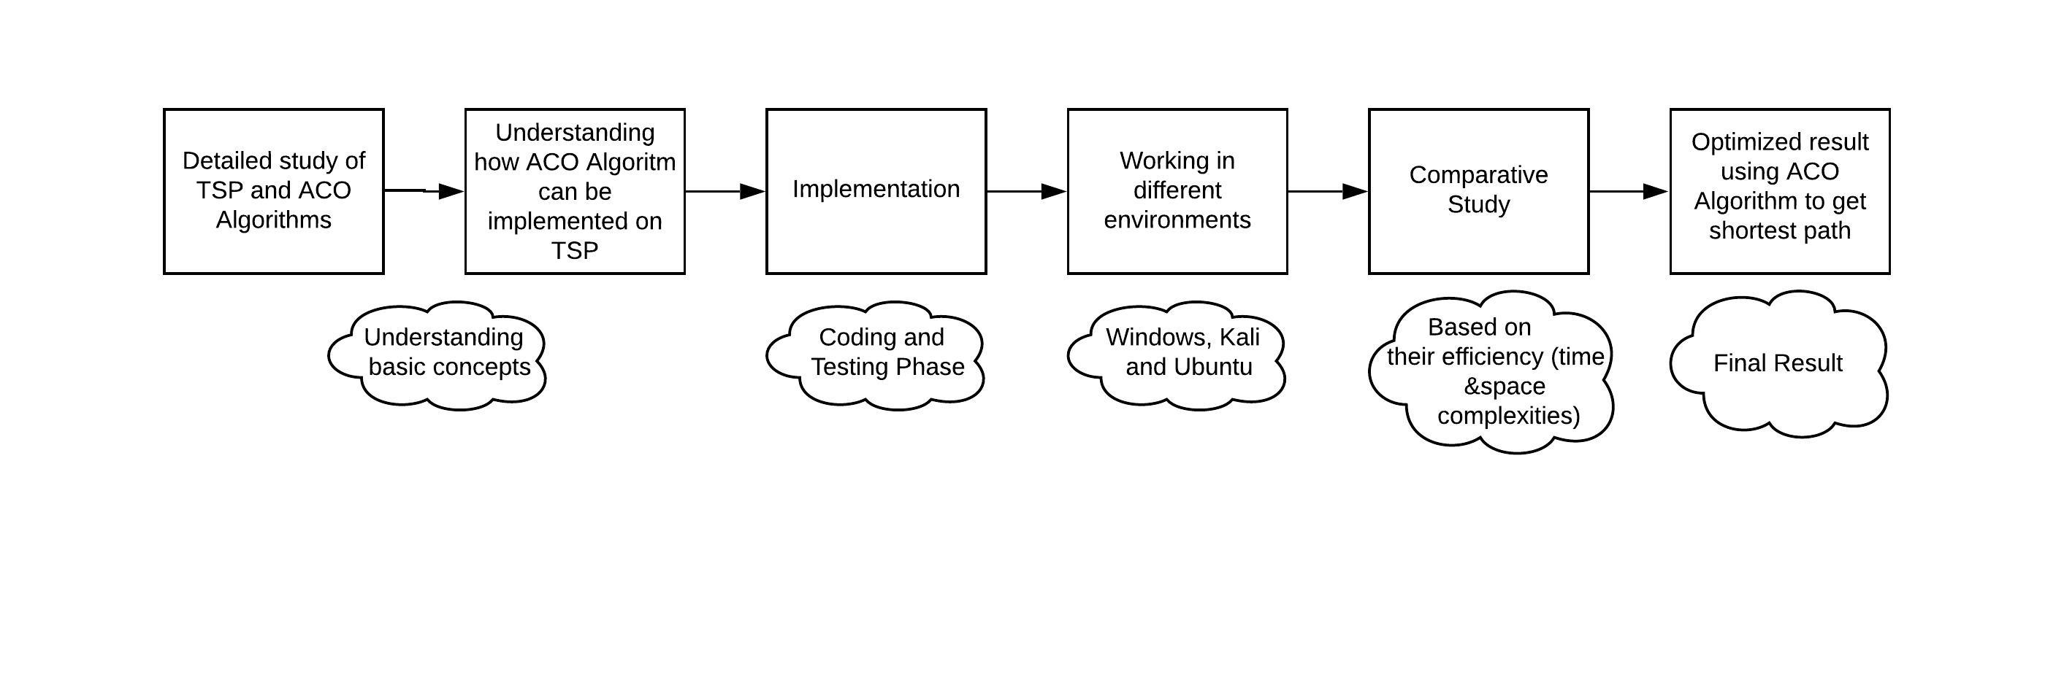

**6 System Requirements**

* Hardware Interface:
  + 64 bits processor architecture supported by Windows, Ubunto or Kali
  + Minimum RAM requirement for proper functioning is 500 MB.
* Software Interface:
  + This system is develop in C programming language.
  + GCC Compiler

**7 Schedule (Pert Chart)**

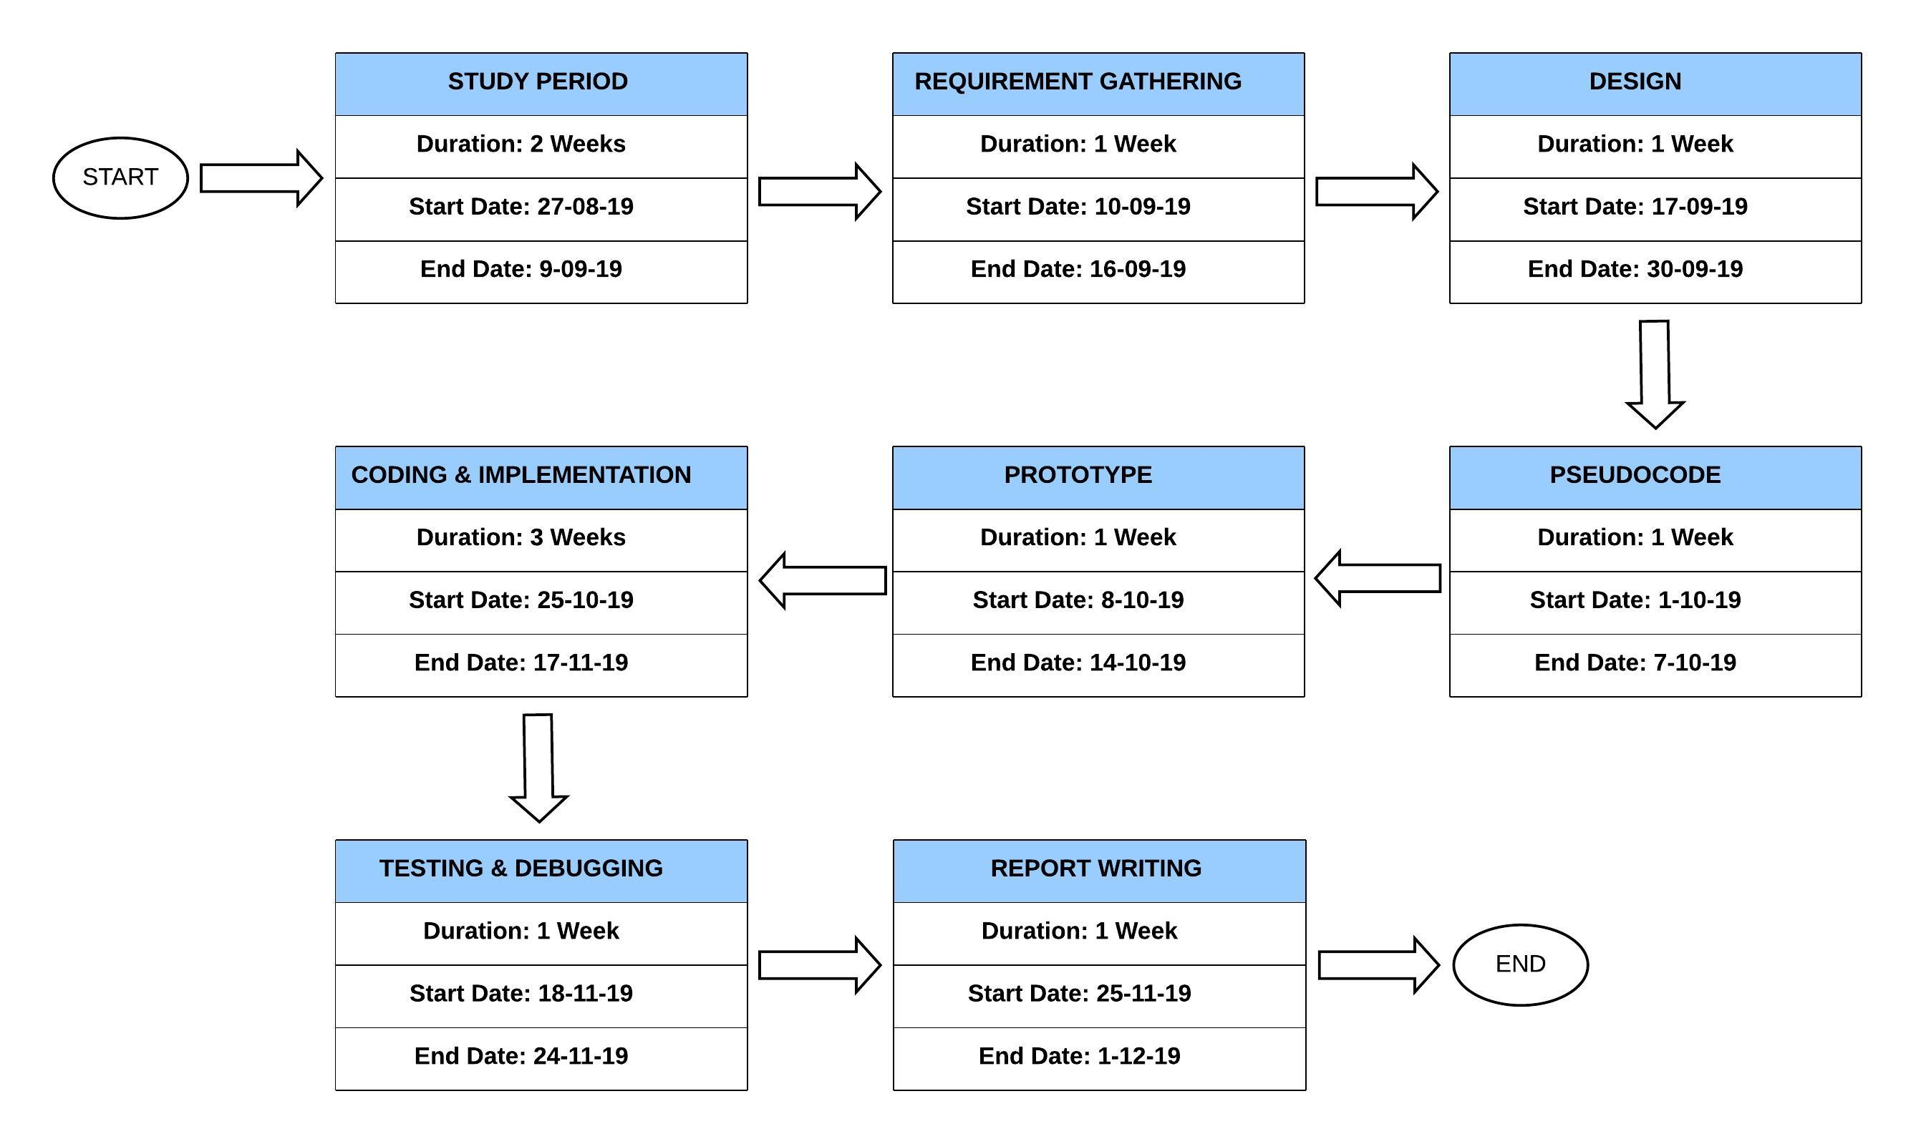

**8 References**

1. M. Alhanjouri, “International Journal of Advanced Research in Optimization Techniques for Solving Travelling Salesman Problem,” no. November, 2018.
2. S. G. Yaseen, “Ant Colony Optimization,” vol. 8, no. 6, pp. 351–357, 2008.
3. https://towardsdatascience.com/types-of-optimization-algorithms\\used-inneural-networks-and-ways-to-optimize-gradient-95ae5d39529f.
4. <https://www.sciencedirect.com/science/article/pii/S1002007108002736>
5. <https://ljvmiranda921.github.io/notebook/2017/01/18/ant-colony-optimization-tsp/>
6. <https://www.omicsonline.org/open-access/solving-traveling-salesmen-problem-using-ant-colony-optimizationalgorithm-2168-9679-1000260.php?aid=64963>
7. <https://ieeexplore.ieee.org/document/4668027>

**Synopsis Draft verified by**

**Project Guide HOD**

**(Name & Sign) (Dept. of Systemics)**